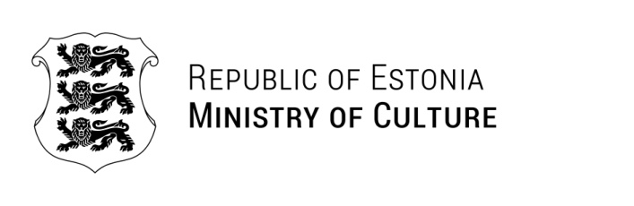

To Whom it may concern
 | 10.03.2025 | No 9-7/305-1

Confirmation letter (Musikfest Bremen)

The Estonian Ministry of Culture hereby confirms that the Estonian Philharmonic Chamber Choir’s concert at the 36. Musikfest Bremen 2025, with the festival taking place between 16.08.-06.09.2025, will be financed to the extent of 50% from the state budget of the Republic of Estonia.

Yours sincerely,

{Allkirjastaja nimi}
Head of the Arts Department
acting as Undersecretary for Creativity

